DIVINITY ROXX
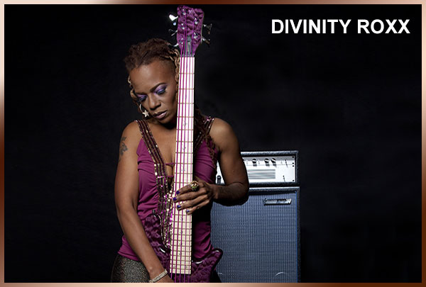

Divinity Roxx is a dynamic musical artist who counts world renowned bass player, acclaimed rapper and producer as credits on her resume. Growing up in Atlanta, GA, Divinity explored music from a young age. She started rapping in junior high school and began playing the bass in college. When Divinity combined the two skills, she found her unique ability to play ferocious bass lines and rap simultaneously. This display of finesse and dexterity got the attention of Victor Wooten, arguably one of the best bass-players in the world. Divinity was a featured part of Wooten's live show from 2001 through 2005 and can be heard on two of his albums, Live In America (2001, Compass) and Soul Circus (2005, Vanguard). In 2006 Divinity joined Beyonce’s all-girl band and has been touring the world with this global megastar, playing to sold-out crowds from Australia to Brazil. Divinity is a featured part of Beyonce’s current DVD collection, including the Beyonce Experience (2008), I Am…Sasha Fierce (2010), and I Am…Yours (2010). Divinity has recently developed her own signature bass guitar with Warwick and is currently working on a solo CD set for release in 2011.
He of course has his own projects. Pedra Preta, a trio formed with two great musicians from Switzerland, Iyexà, a pure afro-brazilian group, formed in Barcelona, and a duet with Portuguese Accordion player, João Frade.

